**Droplet Evaporation on Hot Microstructured Superhydrophobic Surfaces:**

**Analysis of Evaporation from Droplet Cap and Base Surfaces**

Wenge Huang a †, Xukun He a †, Yahua Liu d, Jiangtao Cheng a, b, c, *

a Department of Mechanical Engineering, Virginia Tech, Blacksburg, VA 24061, USA

b Macromolecules Innovation Institute, Virginia Tech, Blacksburg, VA 24061, USA

c Center for Soft Matter and Biological Physics, Virginia Tech, Blacksburg, VA 24061, USA

d Key Laboratory for Non-traditional Machining Technology of Ministry of Education, Dalian University of Technology, Dalian 116024, China

*Corresponding author. E-mail: [chengjt@vt.edu](mailto:chengjt@vt.edu); Phone: 540-231-4164

**Nomenclature**

**Abstract**

In this study, evaporation of sessile water droplets on hot micro-structured superhydrophobic surfaces is experimentally and theoretically investigated. For the first time, two distinguished components of heat and mass transfer, *i.e*., from the droplet cap surface and the base surface, during the droplet evaporation are systematically studied. Water droplets with volume of 4 μL are placed on silicon-based micropillared substrates with the substrate temperature varying from 40 °C to 120 °C. A comprehensive thermal circuit model is developed to analyze the effects of micropillars and substrate temperature on the sessile droplet evaporation. Droplet cap surface temperature is predicted, matching well with the experimental results for droplet evaporation on the substrates heated in the range of 40 °C - 80 °C. Evaporation rates from the droplet cap surface and the base surface are calculated, respectively. We found that the decrease of evaporation rate from the droplet base surface dominates the decrease of total evaporation rate in the constant contact radius mode and the decrease of evaporation rate from droplet cap surface is dominant in the constant contact angle mode. The effects of internal fluid motion of droplet are considered for droplet evaporation on substrate at 100 °C and 120 °C, and an effective thermal conductivity is employed as a correction factor for the thermal circuit model to account for the effect of convection heat transfer inside the droplet body. Temperature differences between the droplet base and the substrate surface are estimated to be about 2 °C, 5 °C, 8 °C, 12.5 °C and 18 °C for the droplet evaporation on the substrate heated at 40 °C, 60 °C, 80 °C, 100 °C, and 120 °C, respectively, which may elucidate the delayed or depressed boiling of water droplets on a heated surface.

**Keywords:** droplet evaporation, microstructured surfaces, superhydrophobic surfaces, thermal circuit analysis.

**1. Introduction**

Evaporation of sessile liquid droplets is a ubiquitous natural phenomenon, which holds an important role in a variety of applications, including inkjet printing[1, 2], DNA mapping[3], spray cooling[4], and microparticle detection[5]. Meanwhile, sessile droplet evaporation is a complex phenomenon controlled by several interdependent factors, such as the droplet contact angle and contact radius[6], contact line motion[7-9], substrate structure[10-15], temperature[16-21] and the surrounding environment[22-24].

Since the seminal work of Picknett and Bexon in 1977[25], sessile droplet evaporation on smooth surface has been systematically analyzed, in which droplet evaporation was distinguished into three evaporation modes: (1) the constant contact radius (CCR) mode: the droplet contact line is pinned with a constant contact radius while the contact angle keeps decreasing; (2) the constant contact angle (CCA) mode: once the contact angle approaches the receding contact angle, the contact line keeps receding with unchanged contact angle; (3) the mixed mode: both the contact radius and contact angle decrease near the end of evaporation. In several recent studies about the droplet evaporation on structured superhydrophobic surfaces, a special stick-slip mode[26] was observed, in which droplet contact line is moved by the pinning and depinning force alternately.

Several theoretical models have been proposed to predict the evaporation rate of sessile droplets on various surfaces. Also in the classical work of Picknett and Bexon[25], the sessile droplet evaporation at room temperature was firstly assumed to be driven by the vapor diffusion, ignoring the heat transfer and convective flow inside/outside the droplet. And the analytic evaporation rate could be obtained based on an analogy between the concentration field and the electrostatic field[27]. During the past two decades, this diffusion-driven model was extensively studied, which has been applied on modeling the evaporation of sessile droplets with the arbitrary contact angle in the CCR mode or with a slipping contact line in the CCA mode. Compared with the experimental data, the excellent agreement of the predicted evaporation rate confirms the validity of the diffusion-driven model of sessile droplet evaporation not only on hydrophilic surfaces[28-30] but also on hydrophobic surfaces[21, 31].

However, when the diffusion-driven model was employed for analyzing sessile droplet evaporation on non-wetting surfaces with microstructure[32], especially on the heated superhydrophobic surfaces, an overestimation of evaporation rate was observed by Garimalla and Aldhaleai[33-35]. This deviation of the predicted evaporation rate should result from the evaporative cooling, giving rise to a temperature reduction on the liquid-vapor interface, which is in contradiction to the pivotal assumption in the classical diffusion-driven model that the temperature of the droplet surface is constant and same as the substrate temperature[28-30]. For instance, the maximum temperature mismatch of ~20 °C between the droplet surface and the substrate was experimentally observed when the substrate was heated at 70 °C[16]. Furthermore, the availability of the diffusion-driven model might become worse when the wetting states of droplet on micro-structured surfaces, *i.e*., the Cassie state or the Wenzel state, are considered. For a sessile droplet evaporates in the Cassie state, the existence of the air/vapor cushion layer between the droplet base and the microstructures would lead to two different components of droplet evaporation, *i.e.*, from the liquid-vapor interface at (1) the droplet cap and (2) the droplet base. However, the effect of this extra evaporative interface from the droplet base on sessile droplet evaporation on superhydrophobic surfaces was generally ignored in the majority of previous work[33, 36, 37]. Indeed, in recent works of Wang and Kim[17, 38, 39], the non-negligible evaporation flux through the vapor-liquid interface over the substrate cavity has been experimentally confirmed on heated superhydrophobic surfaces, whereas these works mainly focused on the wetting or dynamics of the evaporating droplet. Therefore, a systematic study about droplet evaporation on heated superhydrophobic surfaces by considering the comprehensive effects of multiple and discontinuous liquid-vapor interfaces at the droplet base and the droplet cap is entailed.

In this paper, the evaporation of water droplet on hot micro-structured superhydrophobic substrates is experimentally and theoretically investigated. The water droplets of 4 μL were placed on the superhydrophobic substrates heated at 40 °C, 60, and 80 °C, respectively. The droplet evaporated in the Cassie state during the majority of evaporation time and transited to the Wenzel state at the very end of the evaporation. Based on a comprehensive thermal resistance analysis, a thermal circuit model has been developed to predict the droplet cap surface temperature and to calculate the evaporation rate from the droplet cap surface and the base surface, respectively. An evaporation ratio 𝜑, which is defined as the ratio of evaporation rates from the droplet base surface and the total evaporation rate, is analyzed in the CCR mode and the CCA mode, respectively. And we found that the droplet surface temperature predicted by the thermal circuit model matches well with the experimental results. Both the evaporation rates from the droplet cap surface and the base surface decrease during the evaporation. The decrease of the evaporation rate from the droplet base surface dominates the decrease of total evaporation rate in the CCR mode, whereas the decrease of evaporation rate from the droplet cap surface is dominant in the CCA mode. The evaporation ratio 𝜑 decreases in the CCR mode and increases approaching the end of the CCA mode. Then the substrate was further heated from 80 °C to 120 °C until a further small rise of the substrate temperature would otherwise lead to the boiling of the droplet. A remarkable deviation between the experimentally measured droplet surface temperature and the predicted one was observed for droplet evaporation at such high substrate temperatures because of the internal fluid convection *i.e*., Marangoni effect, of the water droplet. As such, an effective thermal conductivity was employed by us as a correction factor for the thermal circuit model to account for the effect of convection heat transfer inside the water droplet. The average temperatures of the droplet base surface were calculated and the temperature differences between the droplet base and the substrate base were about 12.5 °C and 18 °C, respectively, for droplet evaporation on substrates heated at 100 °C and 120 °C, which explains the depressed or delayed boiling of droplets on the superheated substrates. This study could deepen our understanding of droplet evaporation on hot microstructured superhydrophobic surfaces and provide us a potential way to control the sessile droplet evaporation on non-wetting surfaces.

**2. Experimental methodology**

**2.1 Substrates**

Silicon-based substrates with square pattern micropillars were manufactured by standard contact photolithography process and deep reactive ion etching method[5, 40-42]. Three kinds of substrate with thickness of 1 mm and textured with cylindrical micropillar arrays with increasing micropillar periodicity (*P*) were used in this study. The geometry information of the substrates is listed in Table 1 and the scanning electron microscope (SEM) image of one substrate sample used by us is shown in Fig. 1. All the substrates were conformally coated with silane (Trichloro (1H,1H,2H,2H-per fluorooctyl)-silane, Sigma-Aldrich) using standard chemical vapor deposition (CVD) process for superhydrophobicity[43]. Then the substrates were placed on a 100 °C hot plate for 60 min baking. Water droplet exhibits a contact angle about 155° on all the as-prepared substrates. To mitigate the sample edge effect on the droplet evaporation process, substrate samples were cut into square pieces with the dimension of 2 cm 2 cm and water droplets were deposited at the center of the substrate.

**Table 1.** Micropillar diameter, periodicity and height of different sample substrates

|  |  |  |  |
| --- | --- | --- | --- |
| Substrate | Micropillar diameter D (μm) | Micropillar periodicity P (μm) | Micropillar height H (μm) |
| Sample 1 | 20 | 40 | 40 |
| Sample 2 | 20 | 50 | 40 |
| Sample 3 | 20 | 60 | 40 |

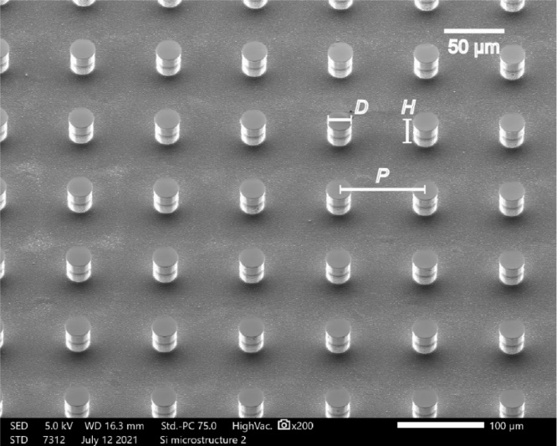

**Figure 1.** Scanning electron micrograph of the sample device used in this study.

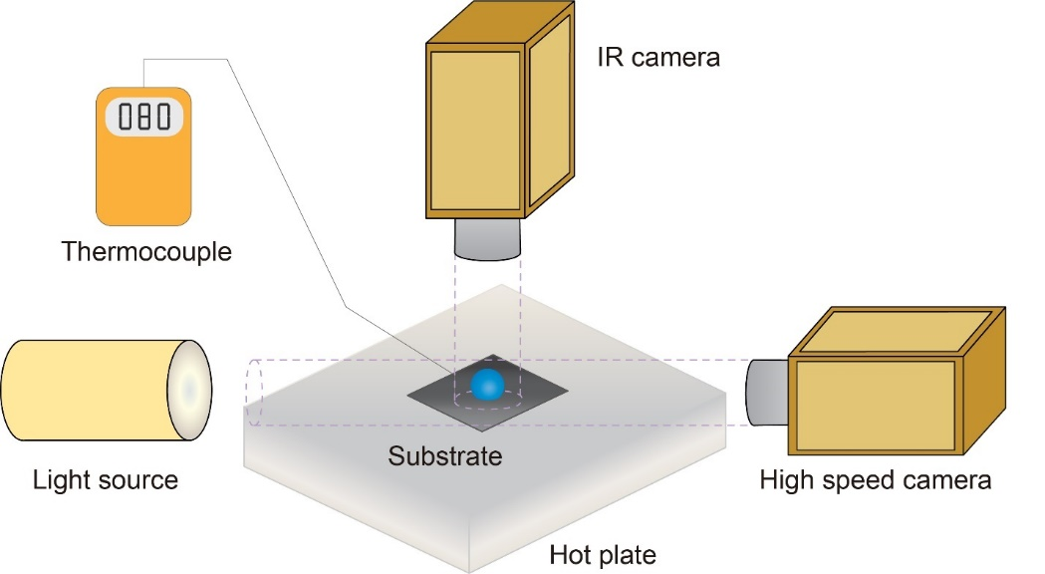

**Figure 2.** Schematic diagram of the experimental setup including cameras, substrate, hot plate, light source and thermocouple.

**2.2 Experimental setup**

Fig. 2 shows the schematic of the experimental setup. In this study, deionized (DI) water (Type 1, >18 MΩ cm resistivity) was used as the liquid and a DI water droplet of 4 ± 0.1 μL generated by a syringe pump (EW-74905, Cole-Parmer Corporation) was gently dispensed on the center of the heated superhydrophobic micro-structured substrate for evaporation study. Five trials were carried out for each droplet evaporation process to make sure the evaporation process is stable and repeatable. Because of the small volume, the shape of the sessile water droplet resembled a spherical cap. The substrates were affixed on a hot plate and a K-type thermocouple with 0.5 °C uncertainty was used to measure the surface temperature of the substrate during the experiment. The base temperature of the substrate was maintained at a constant level on the hot plate ranging from 40 °C to 120 °C, beyond which a small temperature increase would otherwise lead to the onset of boiling of the sessile droplet. Two cameras parallel and normal to the substrate were used to record the evaporation process of the droplets. A calibrated infrared (IR) camera (FILR A5) was fixed on the top of the droplet and normal to the substrate to measure the surface temperature evolution of the droplet. Because of the superhydrophobicity of the substrate, a droplet sitting on the substrate exhibited a large contact angle and only the upper hemispherical surface of the droplet can be focused by the IR camera. Regardless of the influence of droplet internal flow on its surface temperature distribution, the temperature measured by the IR camera was understood as the average surface temperature of the droplet upper hemispherical cap. A high-speed CCD camera mated with a contact angle measurement system (Theta Lite, OneAttension Corporation) was used to measure the evolution of the droplet profile. The high-speed camera was fixed parallel to the substrate to capture the images of the evaporating droplet. The droplet shape is assumed to be axisymmetric. Based on the captured snapshots, the water droplet was divided into layers and the local height and diameter of each water layer was tested from the images. The volume of the droplet was calculated by integrating the discrete water layers. With the snapshots obtained by the high-speed camera, the transient droplet volume, contact angle, contact radius and droplet height were collected. The ambient temperature and relative humidity were maintained at °C and , respectively.

**3.** **Experimental model**

**3.1 Wetting state**

Droplets exhibited different wetting states on the microstructured substrate during the evaporation. It was observed that there existed specific air/vapor cavities underneath the droplet during the majority duration of the evaporation process, which means the droplet was at least partially in the Cassie state. At the very end of the evaporation, water liquid filled the cavities underneath the droplet and the droplet was in the Wenzel state during this period. The snapshots of the water droplet during evaporation are shown in the supplementary information. Though droplet exhibited two wetting states during the evaporation, the droplet was in the Cassie state during most of the evaporation process. We mainly focus on the evaporation process of the droplet in the Cassie state and the thermal circuit model developed by us is based on the Cassie state droplets in this work.

**3.2 Energy balance model**

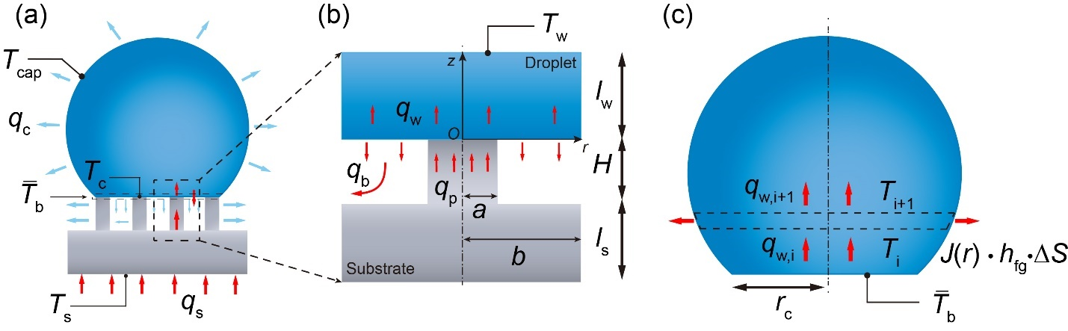

**Figure 3.** (a) Diagram of droplet evaporation on hot microstructured superhydrophobic substrate. (b) Diagram of heat transfer from a micropillar unit into droplet base surface. (c) Diagram of heat transfer inside the water droplet.

When a droplet is deposited on the hot substrate, heat will transfer from the hot plate through the micro-structured substrate into the sessile droplet due to the temperature difference between the hot substate base and the droplet surface as shown in Fig. 3(a). This heat transfer process will result in the temperature increase inside the droplet and accelerate the heat and mass transfer between the droplet and the ambient air. The energy balance equation of the droplet can be derived as:

(1)

where is the overall transfer rate from the substrate to the droplet; is the energy transfer rate for the bulk water temperature increase; is the convective heat transfer rate between the water droplet and the ambient air; is the radiation heat transfer rate from the water droplet to the ambient; and is the heat transfer rate of the evaporation. So, we have:

(2)

(3)

(4)

(5)

where , , , V and are the specific heat capacity, water density, droplet cap surface temperature, volume and latent heat of the water droplet, respectively; is the emissivity of the water droplet surface and is the Stefan-Boltzmann constant; *S* is the liquid-vapor interface area and is the natural convection heat transfer coefficient of the ambient air.

Because of the high efficiency of phase change heat transfer process, the heat transfer rate induced by evaporation is dominant over the heat transfer rate of the other three types. Thus, the overall heat transfer from the substrate to the water droplet can be estimated as the heat released from the droplet to the ambient by evaporation. Therefore, the energy balance equation can be rewritten as:

(6)

**3.3 Evaporation from droplet base surface**

Evaporation of droplet happens at the liquid-vapor interface. For a Cassie state droplet on micro-structured substrate, there exist air/vapor cavities between the droplet base and the substrate. Different from a sessile droplet on a smooth surface, with which the droplet base is in direct contact, only part of the droplet base is in touch with the surface roughness on a micro-structured substrate. The existence of liquid-vapor interface at the droplet base surface leads to evaporation at the droplet base surface. In previous studies of the Cassie state droplet evaporation on micro-structured surfaces at room temperature, the evaporation from droplet base surface was generally neglected and only the evaporation from the droplet cap was taken in to consideration[36, 37]. It is reasonable to neglect the evaporation from the droplet base at room temperature considering the relatively small liquid-vapor interface area and the high relative humidity in the air/vapor cavities. However, for a Cassie state droplet evaporation on a hot micro-structured substrate, the temperature increase of the substrate will cause a direct temperature rise of the droplet base, making the evaporation from the droplet base unneglectable. As shown in Fig. 3(a), both the evaporation from the droplet cap and the base surface should be taken into account for the evaporation of a Cassie state droplet on hot micro-structured surfaces.

Because of the periodicity of the micropillar arrays, the heat transfer process in one unit of micropillar cell can represent the characteristic of the heat transfer process between the droplet base and the substrate micropillars[17]. Thus, we focus on one unit cell of the micropillar and the heat transfer from one unit micropillar cell into the droplet base surface is illustrated in Fig. 3(b). A micropillar cell consists of one micropillar and one air/vapor cavity around the micropillar. In general, heat transfer from both the silicon substrate and the vapor cavity should be considered. The thermal resistance of the vapor layer is much larger than the thermal resistance of the silicon micropillar due to the order of magnitude difference in the thermal conductivities of silicon micropillars (100 Wm­-1K-1)[17] and water vapor (0.025 Wm­-1K-1)[38]. Therefore, it is reasonable to assume that heat primarily conducts from the micropillar to the water droplet whereas the vapor-solid interface of the cavity can be regarded as adiabatic.

As mentioned before, heat transferred from the substrate is equal to that released to the ambient air. Thus, we can calculate the substrate heat transfer rate by obtaining the evaporation heat transfer rate of the water droplet based on the decreasing of droplet volume (Eq. 5). Thus, heat transfer rate in one unit cell could be calculated as:

(7)

where *N* is the total number of the micropillars underneath the droplet, which is calculated by the ratio of the droplet apparent contact area and one unit cell area.

The thermal resistance of the silicon substrate per unit cell could be calculated as:

(8)

where is the thermal conductivity of silicon and  is the thickness of the silicon substrate excluding the height of micropillars.

Based on the energy balance inside the silicon substrate, the temperature on the tip of the micropillar could be calculated as:

(9)

Considering the heat flux at the liquid-solid interface, the contact temperature at the liquid vapor interface is given by[15, 44-46]:

(10)

where , *c* and *k* are the density, specific heat and thermal conductivity of water (W) and silicon (Si), respectively; is the initial temperature of the water droplet.

To study the temperature distribution near the liquid-solid interface, *i.e.*, the top surface of micropillar contacting with the droplet base, a thin water layer with a thickness of in a unit cell (Fig. 3) is considered. Assuming convection heat transfer is secondary in this water film, the conductive heat transfer equation therein is:

(11)

Due to the relatively small size of the micropillar, the heat flux across the liquid-solid interface and liquid-vapor interface in a unit cell could be assumed as uniform. As a result, we have the first boundary condition:

(12)

where is the thermal conductivity of water, *a* is the radius of the micropillar and *b* is the radius of one unit cell[47], is the heat transfer rate from droplet base surface within one unit cell as shown in Fig. 3(b).

Temperature inside the water layer is assumed to become uniform soon. Hence, a uniform temperature boundary could be assumed at :

(13)

Moreover, considering the periodicity of the unit cell, we assume the adiabatic boundary between the chosen unit cell and its neighboring cell inside the water layer. Thus, we obtain the adiabatic boundary condition:

(14)

Solving the heat transfer equation Eq. (11) with the three boundary conditions Eqs. (12)-(14), we can obtain the temperature distribution inside the water layer as:

(15)

where is the evaporation ratio, *i.e.*, the heat transfer across the droplet base over the overall heat transfer from the substrate to the droplet. Also and are the first kind Bessel functions with orders of 0 and 1, respectively, is the nth root of 0[48].

The temperature at the droplet base at is calculated as:

(16)

Thus, the average temperature of the droplet base could be obtained as:

(17a)

(17b)

The average temperature of the solid-liquid interface at the droplet base could be estimated as:

(18a)

(18b)

The temperature at the solid-liquid interface should be same as the contact temperature, we have:

(19)

Thus, the average temperature of the water droplet base is given by:

(20)

**3.4 Evaporation from droplet cap surface**

During evaporation of a sessile water droplet especially at a relatively low temperature, the one-dimensional heat conduction process inside the droplet is shown in Fig. 3(c). The water droplet is discretized into a series of thin layers (*i* = 1, …, M, where M is the number of discrete water layer in the upper hemisphere of the droplet spherical cap) parallel to the substrate. Here, temperatures at the bottom surface ) and the top surface of the *i*th water layer are assumed to be laterally uniform, respectively. Then, in the *i*th water layer, we have:

(21)

where is the thermal resistance of the *i*th water layer

(22)

where is the thickness of each discrete water layer and is the local radius of the *i*th water layer.

Taking the *i*th layer as the control volume, heat transfer into the *i*th water layer from the bottom surface () is balanced by the heat transfer to the top surface () and the evaporation from the side surface. The energy balance in the *i*th water layer is:

(23)

where is the side surface area of the water layer, is the latent heat, and is the local evaporation mass flux.

Then we applied the diffusion-driven model to estimate the local evaporation flux, which is the solution to the Laplace equation based on Fick’s law of water vapor diffusion around the droplet. Hence, the exact solution of the local evaporation flux is given by:

(24)

where is the temperature at the side surface, is the saturated vapor concentration, is the diffusion coefficient of vapor, and is the relative humidity.

The evaporation heat transfer rate from the droplet cap surface is calculated by integrating all the local evaporation rates:

(25)

The heat transferred from the droplet cap surface should be the same as the heat transferred through the water droplet:

(26)

As mentioned before, the experimental temperature measured by the IR camera is taken as the average temperature of the upper hemispherical surface. With the average base temperature of the water droplet obtained, we can calculate the surface temperature distribution based on the heat transfer equation Eq. (21) for the discretized water layers. Thus, we can approximate the average temperature of the upper hemispherical surface of the droplet as:

(27)

where is the radius of the spherical cap.

**3.5. Algorithm for calculating the surface temperature and evaporation ratio**

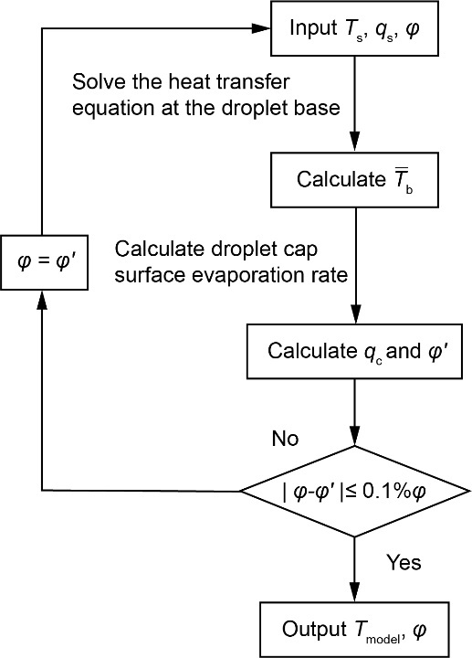

**Figure 4.** Algorithm for calculating the droplet surface temperature and evaporation ratio which is defined as the ratio of evaporation rate from the droplet base surface to the heat transfer rate through the micropillar in one unit cell.

The algorithm for calculating the droplet surface temperature and the evaporation ratio is shown in Fig. 4. The base temperature of the substrate is measured by the thermocouple and the heat transfer rate from the substrate is obtained by calculating the transient droplet volume decrease rate based on Eq. (5). An initial value of the evaporation ratio is used to solve the heat transfer equation at the droplet base. The heat transfer equation Eq. (11) can be solved according to the boundary conditions. Thus, the temperature distribution at the droplet base surface Eq. (16) is obtained and consequently the average temperature of the droplet base is calculated. Based on the one-dimensional conduction heat transfer model inside the water droplet, the nonuniform surface temperature distribution of the droplet cap can be solved. With the droplet surface temperature distribution known, the modified diffusion-driven heat transfer model with the nonuniform surface temperature is used to calculate the evaporation flux from the droplet cap surface. It is not practical to directly calculate the evaporation rate from the droplet base because of the complex micro-pillared structure in this study. Thus, the evaporation rate from the droplet base surface is taken as the difference of the total evaporation rate and the evaporation rate from the droplet cap surface calculated by Eq. (25). The accuracy of the evaporation rate from the droplet base surface dependents on the accuracy of the calculated evaporation rate from the droplet cap surface. With the surface temperature distribution taken in to consideration, Gleason and Putnam reported that the evaporation rate errors for droplet evaporation on a 50 °C substrate and a 65 °C substrate were 1.84% and 2.83%, respectively. Therefore it is reasonable to predict the droplet cap surface evaporation rate based on the diffusion-driven model and the surface temperature distribution. Thus, the evaporation rate from the droplet cap surface can be estimated and consequently the evaporation ratio is obtained. After the iteration loop achieves convergence, both the stable evaporation ratio and temperature distribution on the droplet cap surface are obtained. With the temperature distribution of the droplet cap surface obtained, the average temperature of the upper hemispherical surface of the droplet cap surface is calculated and compared with the experimental results for the validation of our thermal circuit model.

**4. Result and discussion**

**4.1. Droplet evaporation dynamics**

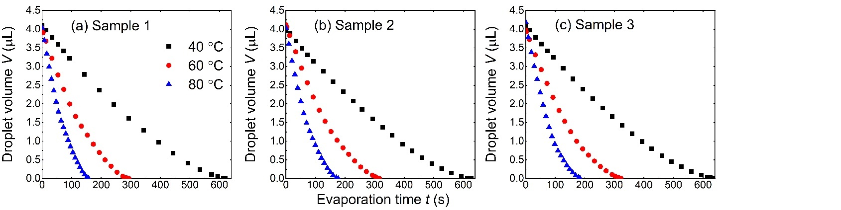

**Figure 5.** Temporal evolution of droplet volume on different substrates: (a) sample 1, (b) sample 2 and (c) sample 3. The substrate bases are heated to 40 °C, 60 °C and 80 °C, respectively, on each sample.

The variation of droplet volume with respect to evaporation time on different substrates is shown in Fig. 5. Droplet volume decreases nonlinearly during the evaporation. The total evaporation time decreases with the rise of the substrate base temperature. The total evaporation time increases with the increase of the substrate periodicity when the substrate base temperature is kept the same. With the same substrate base temperature, droplet evaporation on sample 3 (60 μm periodicity) has the longest total evaporation time and on sample 1 (40 μm periodicity) has the shortest total evaporation time. This increase of total evaporation time is ascribed to the increase of the thermal resistance between the droplet base and the substrate, which is caused by the increase of the substrate periodicity. The total evaporation time of droplet evaporation on different sample substrates is shown in Table 2.

**Table 2.** Total evaporation time for water droplet of 4 mL on micro-pillared substrates with different base temperatures.

|  |  |  |
| --- | --- | --- |
| Substrate | Substrate base temperature (°C) | Total evaporation time (s) |
| Sample 1 | |  | | --- | | 40 | | 60 | | 80 | | |  | | --- | | 620.1 | | 293.3 | | 156.8 | |
| Sample 2 | |  | | --- | | 40 | | 60 | | 80 | | |  | | --- | | 627.1 | | 312.2 | | 177.1 | |
| Sample 3 | |  | | --- | | 40 | | 60 | | 80 | | |  | | --- | | 633.3 | | 322.3 | | 184.1 | |

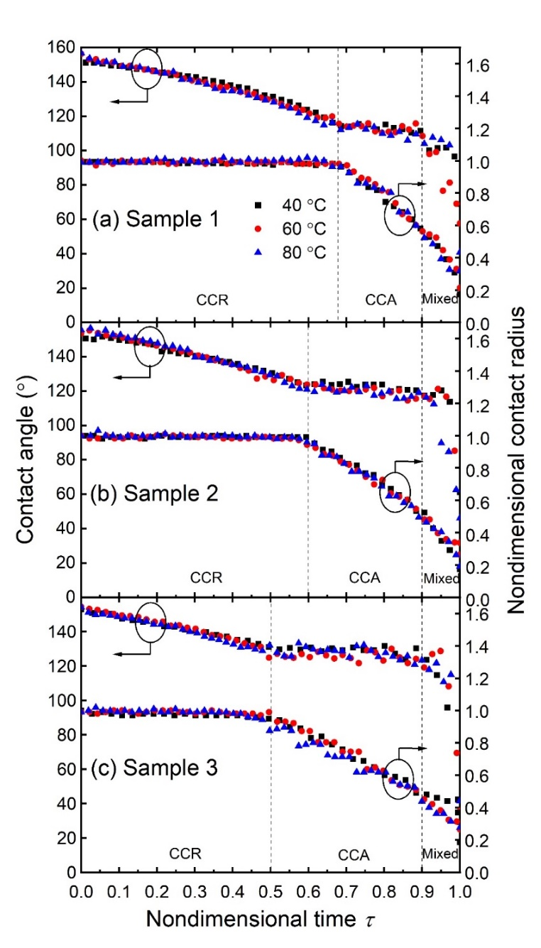

**Figure 6.** Evolution of droplet contact angle and nondimensional contact radius versus nondimensional time on different sample substrates: (a) sample 1, (b) sample 2 and (c) sample 3. The substrate bases are heated to 40 °C, 60 °C and 80 °C, respectively.

The evolution of droplet contact angle and nondimensional contact radius with nondimensional time is shown in Fig. 6. Here the nondimensional contact radius is defined as the ratio of the contact radius to the initial contact radius, and the nondimensional time is defined as the ratio of the evaporation time to the total evaporation time. It can be seen from Fig. 6 that the evolutions of droplet transient contact angle and nondimensional contact radius are almost the same for droplet evaporation on each sample substrate with different base temperatures. For droplet evaporation on sample 1 (Fig. 6a), the droplet contact angle decreased continuously during the first 68% part of the total evaporation time while the contact radius was kept unchanged, which is the constant contact radius (CCR) mode for droplet evaporation. After the contact angle reached the receding contact angle, the contact angle stopped decreasing and was maintained at a constant level while the contact radius started to decrease, which is the constant contact angle (CCA) mode for the droplet evaporation. The droplet evaporation was in the CCA mode till the nondimensional time approached 0.9. Then, both the contact angle and contact radius started decreasing, which is the mixed mode for the droplet evaporation. For droplet evaporation on the same sample with different substrate temperatures, the evaporation process had almost the same compositions of the CCR, CCA and mixed modes, indicating that the substrate structure is more influential on the evaporation mode transition than the substrate temperature at least within a certain range (*i.e.*, 80 °C). The evolutions of droplet contact angle and nondimensional contact radius on sample 2 (Fig. 6b) and sample 3 (Fig. 6c) are similar to the evaporation on sample 1. It is noteworthy that the receding contact angle increases with the increase of the periodicity of micropillars on the substrate. The receding contact angles on sample 1, sample 2 and sample 3 are about 112°, 120° and 128°, respectively. Since the initial contact angles of water droplets on these three samples are almost the same (about 155°), a larger receding contact angle results in the shorter term of the CCR mode. The nondimensional evaporation times for the CCR mode on sample 1, sample 2 and sample 3 are about 0.68, 0.6 and 0.5, respectively.

**4.2. Experimental and modelled droplet cap surface temperature**

The evolutions of droplet cap temperature versus the nondimensional time on samples 1-3 are shown in Fig. 7(a), (b) and (c), respectively. The droplet cap temperature calculated by the thermal circuit model matches well with that measured by the IR camera for droplet evaporation on substrates with temperature at 40 °C, 60 °C and 80 °C, respectively. There exists a large temperature difference between the droplet cap surface and the substrate base, which is caused by the thermal resistances of the water droplet, the evaporation at the droplet surface and the conduction through the silicon substrate. It can be seen in Fig. 7 that the surface temperature increased in the CCR mode and kept essentially constant in the CCA mode. Similar relationships were also observed by Saenz et al.[[49](#_ENREF_49" \o "Sáenz, 2015 #64)] in their numerical simulation of droplet evaporation on heated surfaces. During the CCR mode, the thermal resistance of the droplet decreases with the decreasing droplet volume. Meanwhile, the droplet cap gets closer to the substrate and thus the droplet cap temperature increases. During the CCA mode, the contact area between the droplet and the substrate decreases. As a result, less heat is transferred into the droplet, which hinders the temperature increase of the droplet. The combined effects of the decreasing contact area and decreasing water droplet thermal resistance result in the almost unchanged average surface temperature of the droplet cap during the CCA mode. In the mixed mode, the volume of the evaporating droplet is relatively small (< 0.05 μL) and the evaporation in this mode is not a focus in this discussion.

obtain,the heated at, respectively

The average temperature of the droplet base on different samples and with different substrate temperatures is shown i. There exists an unneglectable temperature mismatch between the droplet base and the substrate base. Though there is a temperature drop through the substrate because of the substrate’s conduction resistance, the large thermal conductivity of silicon (300 W/m·K) should have led to a small thermal resistance (The temperature drop through the substrate is < 1°C based on our calculated results). However, the temperature mismatches between the droplet base and the substrate base are about 2.5 °C, 4.4 °C and 7.5 °C, respectively, on substrates with the base temperature at 40 °C, 60 °C and 80 °C. It is plausible that such an apparent temperature difference between the droplet base and the substrate base may be mainly caused by the evaporation from the droplet base in substrate cavities.

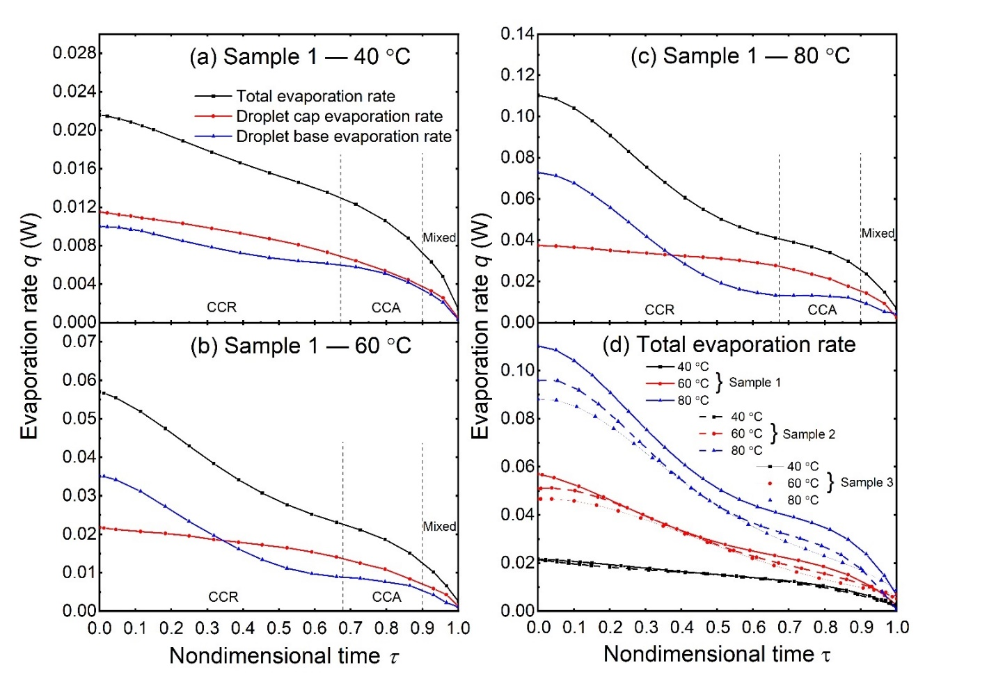

**Figure 8.** (a) Total evaporation rate, droplet cap surface evaporation rate and droplet base evaporation rate on sample 1 with 40 °C substrate base temperature. (b) Total evaporation rate, droplet cap surface evaporation rate and droplet base evaporation rate on sample 1 with 60 °C substrate base temperature. (c) Total evaporation rate, droplet cap surface evaporation rate and droplet base evaporation rate on sample 1 with 80 °C substrate base temperature. (d) Total evaporation rate on samples 1-3 with substrate temperature at 40 °C, 60 °C and 80 °C, respectively.

In Fig. 8(a), (b) and (c), we show the transient evolutions of the total evaporation rate, the evaporation rate from droplet cap and the evaporation rate from droplet base on sample 1 with the substrate base temperature at 40 °C, 60 °C and 80 °C, respectively. The corresponding evaporation rates of droplets on sample 2 and sample 3 are given in the supporting information. The droplet total evaporation rate is calculated by the droplet volume decreasing rate with time. The evaporation rate from droplet cap surface is calculated by the diffusion driven model with the surface temperature distribution predicted by the thermal circuit model. The evaporation rate from the droplet base is the difference between the total evaporation rate and the droplet cap surface evaporation rate. With the increase of the substrate temperature (from 40 °C to 80 °C), both the evaporation rates from the droplet cap and the droplet base increase at a given nondimensional time. Also, both the evaporation rates from the droplet cap and from the droplet base decrease during the droplet evaporation on a substrate with a constant base temperature. It can be seen that the decrease of the droplet cap surface evaporation rate in the CCR mode is very slow whereas the decrease of the droplet base surface evaporation rate in the CCA mode is slow. In the CCR mode, the decrease of the evaporation rate from the droplet cap is mainly caused by the reduction of the droplet contact angle. The contact area between the droplet and the substrate keeps unchanged and the thermal resistances between the droplet base and the substrate also remains unchanged. The decrease of the droplet total evaporation rate means that less heat is transferred from the substrate to the droplet. With the substrate base temperature and the thermal resistances between the droplet and substrate keep unchanged, the decrease of the total evaporation rate is caused by the decrease of the temperature difference between the droplet base surface and the substrate base. In other words, the decrease of the total evaporation rate will cause the increase of droplet base surface temperature, as evidenced in Fig. 11(d). The increase of droplet base temperature will cause the increase of the droplet cap surface temperature, leading to the enhanced evaporation from the droplet cap. The effect of droplet cap temperature increase mitigates the effect of the droplet contact angle decrease on the depressed evaporation from the droplet cap. The combined effects of the contact angle decrease and the droplet cap temperature increase give rise to the slow decrease of the evaporation rate from the droplet cap in the CCR mode. In the CCA mode, the average temperature of the droplet cap keeps essentially constant, which is in contrary to the increase trend of the droplet cap temperature in the CCR mode. Meanwhile, the contact radius of the droplet decreases in the CCA mode, which causes the decrease of heat transfer area between the droplet and the substrate. Thus, the evaporation rate from the droplet cap decreases quickly. In summary, in the CCR mode the decrease of the total evaporation rate of the droplet is mainly caused by the decrease of evaporation rate from the droplet base. Whereas in the CCA mode, the decrease of the total evaporation rate is mainly caused by the decrease of the evaporation rate from the droplet cap.

Droplet evaporation on different substates exhibits distinct evaporation rates as shown in Fig. 8(d). Droplet on sample 1 (40 μm periodicity) has the maximum evaporation rate while droplet has the minimum evaporation rate on sample 3 (60 μm periodicity). Due to the different periodicities of micropillars, the droplet-pillar interface areas are different on different sample substrates. Since droplets on different sample substrates have essentially the same apparent contact area (*i.e*., base area of the droplet), small substrate periodicity means larger heat transfer area between the droplet base and the substrate, *i.e.*, the solid-liquid interface area. The larger solid-liquid interface area results in the higher droplet evaporation rate with the same substrate base temperature.

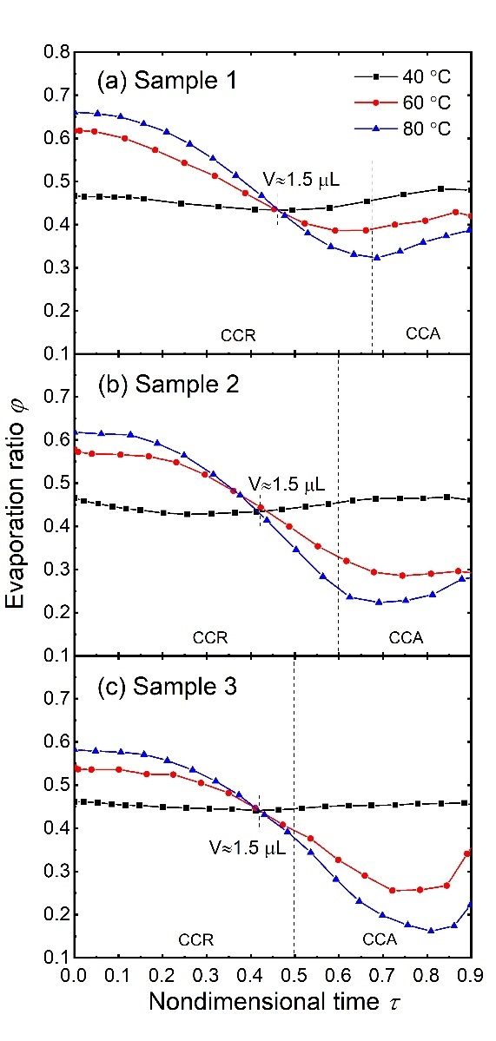

**Figure 9.** Evaporation ratio *φ* of water droplets with respect to nondimensional time on different micro-structured samples with different substrate base temperatures.

defined as the to thee The evaporation ratio *φ* with respect to nondimensional time on different samples with different substrate base temperature is shown in Fig. 9. It can be seen that the evaporation ratio *φ* decreases in the CCR mode and increase in the last period of the CCA mode. That is because of the difference decreasing rate of the evaporation ratio from the droplet cap surface and droplet base surface in the CCR mode and CCA mode. As discussed before, the decrease of the total evaporation rate in the CCR mode is mainly due to the decrease of the evaporation ratio from the droplet base. The quick decrease of evaporation rate from the droplet base determines the decrease of the evaporation ratio in the CCR mode. In the CCA mode, the decrease from the droplet base surface is slow and the main reduction of the total evaporation rate is from the droplet cap. The slow decrease of the evaporation rate from the droplet base leads to the increasing evaporation ratio *φ*. The evaporation ratio *φ* increases with the substrate temperature for droplet evaporation on the same substrate with a relatively large volume (larger than 1.5 μL). The increase of substrate temperature will directly cause a temperature increase of the droplet base and then induce the temperature increase at the droplet cap. Due to the thermal resistance of the droplet bulk, the temperature increase of the droplet cap is smaller than that at the droplet base with the increase of the substrate temperature. Thus, the substrate temperature increase leads to a higher evaporation rate increase at the droplet base for a relatively large volume of droplet. As a result, the evaporation ratio *φ* increase with the rise of the substrate temperature for droplet with a large droplet volume. For droplets with a relatively small volume (smaller than 1.5 μL), the evaporation ratio *φ* decreases with the increasing substrate temperature. Because of the small volume, the thermal resistance of the droplet bulk is comparatively small, and the increase of the substrate temperature will cause a higher temperature increase at the droplet cap for droplets with a small volume. Thus, the increase of the substrate temperature causes a higher evaporation rate increase than at the droplet base surface for droplets with smaller volume. As a result, the evaporation ratio *φ* decreases with rise of the substrate temperature for droplet with a small volume.

**4.3. Effective conductivity of water for evaporation on high temperature substrate**

We further conducted droplet evaporation experiments on the same micro-structured surfaces with even higher temperatures.

Fig. 10(a), (b) and (c) show the droplet cap temperatures during droplet evaporation on different substrates with the substrate temperature at 100 °C and 120 °C, respectively. The dash lines are the droplet cap temperatures calculated by the thermal circuit model. For droplet evaporation on a substrate with relatively low temperatures (40 °C – 80 °C), the droplet cap temperatures calculated by the thermal circuit model match well with the experimental results. However, for droplet evaporation on a high temperature substrate, there exist large derivations between the model-predicted results and the experimental results. These derivations are due to the internal fluid flow of the droplet, which is not taken into account in the thermal circuit model. For droplet evaporation on a substrate with the substrate temperature in the range of 40 °C – 80 °C, the effects of droplet internal flow are not significant for the droplet evaporation. As mentioned by Dash and Garimella, the characteristic velocity of fluid in a 3 μL water droplet evaporating on a 40 °C – 60 °C substrates is of tens of microns per second and the Peclet number is less than 1. Thus, it is reasonable for us to only consider the conduction heat transfer while neglecting the internal convection of the water droplet on a substrate with a relatively low temperatures (40 °C – 80 °C). With the increase of the substrate temperature, more heat is transferred through the droplet and the temperature difference between the droplet top and bottom becomes larger. Fluid motion driven by the temperature gradient in the droplet becomes violent and the characteristic velocity of internal flow increases. Thus, we need to account for the effects of the droplet internal flow field in the thermal circuit model for high temperature evaporation analysis.

In this study, the IR camera is placed on the top of the droplet and the temperature measured by the IR camera is taken as the average temperature of the upper hemispherical surface of the droplet. Correspondingly, the average temperature of the droplet upper hemispherical surface is calculated and compared with the experimental data. The droplet internal flow will mitigate the temperature difference between the droplet top and bottom surfaces and the temperature tested by the IR camera becomes higher than the model-predicted results with only the conduction heat transfer taken into consideration as shown in Fig. 10. To account for the droplet internal flow on the droplet evaporation in the thermal circuit model, we calculated the overall average temperature of the droplet cap instead of only the upper hemispherical surface as the model-predicted surface temperature, which is as shown by the solid lines in Fig. 13(a), (b) and (c). The modified temperature results match well with the experimental data for droplet evaporation on sample 1, 2 and 3 with the substrate base temperature at 100 °C as shown in Fig. 10(a), (b) and (c).

(a) ,andthe ,s-of

But there still exist large derivations between the predicted results and the experimental data for droplet evaporation on substrates with the base temperature heated up to 120 °C. In this scenario, the convection heat transfer in the droplet cannot be neglected. In the thermal circuit model, only the conductive thermal resistance of the droplet is taken into account. Convection inside the droplet will remarkably enhance heat transfer therein and reduce the total thermal resistances of the droplet. Because of the complexity of internal flow, it is not practical to analyze the convection heat transfer simply based on the droplet characteristic velocity. Alternatively, an effective thermal conductivity is adopted to account for both the convection and conduction heat transfer in the droplet. As such, the effective conductivity of an evaporating droplet is defined as:

(28)

where *e* is a coefficient of the effective conductivity.

The effective conductivity is adopted in the thermal circuit model in place of the original water conductivity to account for both the conduction and the convection heat transfer in the droplet. The coefficient of the effective conductivity *e* is larger than 1, which means the effects of convection heat transfer is equivalent as conduction heat transfer and all the effects of conduction heat transfer are added together. The minimum value of *e* allowing for the average difference between the model predicted surface temperature and the experimental value less than 2 °C is chosen as the coefficient of the effective conductivity:

(29)

The coefficient *e* for the effective thermal conductivity of droplet evaporation on samples 1, 2 and 3 with substrate temperature of 120 °C is about 3.2, 2.9 and 2.7, respectively. Our results of coefficient are close to the numerical fitting coefficient 2.72 obtained by Abramzon and Sirignano[50]. The substrates are heated to a high temperature over the boiling temperature of the water droplet. However, no boiling is observed in the droplet even with the substrate temperature reaching 120 °C, which is due to the evaporative cooling at the droplet base. Evaporation at the droplet base will cool down the surface temperature and we calculated the average temperature of the droplet base as shown in Fig. 13(d). For droplet evaporation on the 100 °C substrate, the base surface temperature is about 88 °C and for droplet evaporation on the 120 °C substrate, the base surface temperature is about 102 °C, which is very close to the saturation temperature of 100 °C. Our analysis show that evaporation cooling from the droplet base can significantly delay the onset of droplet boiling with the substrate temperature even close to 120 °C.

**5. Conclusions**

In this paper, the evaporation dynamics of solitary water droplet on hot micro-structured superhydrophobic surfaces have been experimentally and theoretically investigated. Most previous studies of sessile droplet evaporation were carried out at room temperature (20 °C – 30 °C) while the effects of the substrate temperature were ignored[28-31]. Studies about the effects of substrate temperature on the sessile droplet evaporation mainly focused on the droplet Leidenfrost effects[38, 39, 51], in which the droplet is levitated by the evaporating vapor on a very high temperature substrate (200 °C – 300 °C). Only a few studies investigated the sessile droplet evaporation dynamics on hot substrate with relative low temperature (40 °C – 100 °C) and very limited attention has been paid to the evaporation from the droplet base surface whose contribution is amplified by the increase of the substrate temperature. Here, for the first time, we conducted a comprehensive thermal resistance analysis for the sessile droplet evaporation on hot micro-structured superhydrophobic substrates to analyze evaporation from both the droplet cap and the droplet base.

According to our theoretical analysis, droplet cap temperature shows distinct trends in different evaporation modes, *i.e*., droplet cap temperature increases in the CCR mode while keeps essentially constant in the CCA mode. The total evaporation rate of the droplet decreases during the evaporation process. In the CCR mode, the decrease of the total evaporation rate of the droplet is mainly caused by the decrease of evaporation rate from the droplet base. And in the CCA mode the decrease of the total evaporation rate is mainly induced by the decreasing evaporation rate from the droplet cap. The evaporation ratio 𝜑 decreases in the CCR mode and increases approaches the end of the CCA mode. For droplet volume larger than 1.5 μL, 𝜑 increases with the rise of the substrate temperature and for small droplet volume 𝜑 decreases with the rise of the substrate temperature. Internal fluid motion affects the droplet evaporation process on substrates with a high temperature (100 °C–120 °C) and an effective thermal conductivity , which is about three times of water conductivity , is employed by us as a correction factor for the thermal circuit model to account for the convection heat transfer in the water droplet. The average temperature of the droplet base is calculated and a large temperature difference between the droplet base and the substrate is observed. The apparent temperature differences between the droplet base and the substrate base are about 2 °C, 5 °C, 8 °C, 12.5 °C and 18 °C for the sessile droplet on the micro-structured substrate with the base temperature at 40 °C, 60 °C, 80 °C, 100 °C and 120 °C, respectively.

Our study about the sessile droplet evaporation on hot micro-structured superhydrophobic surfaces can deepen our understanding about the heat and mass transfer of the droplet. Meanwhile this thermal circuit model provides us a convenient tool to describe the evaporation dynamics of the sessile droplet on hot micro-structured substrates.

**6. CRediT authorship contribution statement**

†W.H. and X.H. are co-first authors with equal contribution to this work. W.H., X.H and J.C. conceived the research idea. W.H. designed and carried out the experiments, W.H. and X.H. conducted the theoretical analysis. Y.L. fabricated the devices. W.H., X.H. and J.C. wrote the manuscript. Y.L. edited the manuscript.

**7. Declaration of Competing Interest**

None.

**8. Acknowledgment**

This work is financially supported by NSF CBET under grant number 1550299 and NSF ECCS under grant 1808931.

**9. Reference**

[1]. P. Calvert, Inkjet Printing for Materials and Devices, Chem. Mater., 13 (10) (2001) 3299-3305.

[2]. H.-m. Kwon, J.C. Bird, and K.K. Varanasi, Increasing Leidenfrost point using micro-nano hierarchical surface structures, Applied Physics Letters, 103 (20) (2013)

[3]. A. Wu, L. Yu, Z. Li, H. Yang, and E. Wang, Atomic force microscope investigation of large-circle DNA molecules, Anal Biochem, 325 (2) (2004) 293-300.

[4]. W. Jia and H.H. Qiu, Experimental investigation of droplet dynamics and heat transfer in spray cooling, Exp. Therm. Fluid Sci., 27 (7) (2003) 829-838.

[5]. J. Song, W. Cheng, M. Nie, X. He, W. Nam, J. Cheng, and W. Zhou, Partial Leidenfrost Evaporation-Assisted Ultrasensitive Surface-Enhanced Raman Spectroscopy in a Janus Water Droplet on Hierarchical Plasmonic Micro-/Nanostructures, ACS Nano, 14 (8) (2020) 9521-9531.

[6]. S.A. Putnam, A.M. Briones, L.W. Byrd, J.S. Ervin, M.S. Hanchak, A. White, and J.G. Jones, Microdroplet evaporation on superheated surfaces, International Journal of Heat and Mass Transfer, 55 (21) (2012) 5793-5807.

[7]. P. Tsai, R.G. Lammertink, M. Wessling, and D. Lohse, Evaporation-triggered wetting transition for water droplets upon hydrophobic microstructures, Physical review letters, 104 (11) (2010) 116102.

[8]. L. Zhao and J. Cheng, Analyzing the Molecular Kinetics of Water Spreading on Hydrophobic Surfaces via Molecular Dynamics Simulation, Scientific Reports, 7 (1) (2017) 10880.

[9]. L. Zhao and J. Cheng, The mechanism and universal scaling law of the contact line friction for the Cassie-state droplets on nanostructured ultrahydrophobic surfaces, Nanoscale, 10 (14) (2018) 6426-6436.

[10]. X. He, L. Zhao, and J. Cheng, Coalescence-Induced Swift Jumping of Nanodroplets on Curved Surfaces, Langmuir, 35 (30) (2019) 9979-9987.

[11]. L.S. Lam, M. Hodes, and R. Enright, Analysis of Galinstan-Based Microgap Cooling Enhancement Using Structured Surfaces, Journal of Heat Transfer, 137 (9) (2015)

[12]. A. Al-Sharafi, B.S. Yilbas, and H. Ali, Droplet Heat Transfer on Micropost Arrays With Hydrophobic and Hydrophilic Characteristics, Journal of Heat Transfer, 140 (7) (2018)

[13]. C.-C. Hsu, Y.-A. Lee, C.-H. Wu, and C.S.S. Kumar, Self-propelled sessile droplets on a superheated and heterogeneous wetting surface, Colloids and Surfaces A: Physicochemical and Engineering Aspects, 612 (2021)

[14]. F.G.H. Schofield, S.K. Wilson, D. Pritchard, and K. Sefiane, The lifetimes of evaporating sessile droplets are significantly extended by strong thermal effects, Journal of Fluid Mechanics, 851 (2018) 231-244.

[15]. B. Sobac and D. Brutin, Thermal effects of the substrate on water droplet evaporation, Phys Rev E 86 (2 Pt 1) (2012) 021602.

[16]. K. Gleason, H. Voota, and S.A. Putnam, Steady-state droplet evaporation: Contact angle influence on the evaporation efficiency, International Journal of Heat and Mass Transfer, 101 (2016) 418-426.

[17]. S. Adera, R. Raj, R. Enright, and E.N. Wang, Non-wetting droplets on hot superhydrophilic surfaces, Nat. Commun., 4 (2013) 2518.

[18]. R. Hays, D. Maynes, and J. Crockett, Thermal transport to droplets on heated superhydrophobic substrates, Int. J. Heat Mass Transfer, 98 (2016) 70-80.

[19]. M.S. Hanchak, A.M. Briones, J.S. Ervin, and L.W. Byrd, One-dimensional models of nanoliter droplet evaporation from a hot surface in the transition regime, International Journal of Heat and Mass Transfer, 57 (2) (2013) 473-483.

[20]. S.Y. Misyura, Contact angle and droplet heat transfer during evaporation on structured and smooth surfaces of heated wall, Applied Surface Science, 414 (2017) 188-196.

[21]. M.A. Kadhim, N. Kapur, J.L. Summers, and H. Thompson, Experimental and Theoretical Investigation of Droplet Evaporation on Heated Hydrophilic and Hydrophobic Surfaces, Langmuir, 35 (19) (2019) 6256-6266.

[22]. L. Liu, X. Liang, X. Wang, S. Kong, K. Zhang, and M. Mi, Evaporation of a sessile water droplet during depressurization, International Journal of Thermal Sciences, 159 (2021) 106587.

[23]. L. Bansal, S. Chakraborty, and S. Basu, Confinement-induced alterations in the evaporation dynamics of sessile droplets, Soft Matter, 13 (5) (2017) 969-977.

[24]. S. Semenov, F. Carle, M. Medale, and D. Brutin, Boundary conditions for a one-sided numerical model of evaporative instabilities in sessile drops of ethanol on heated substrates, Phys Rev E, 96 (6-1) (2017) 063113.

[25]. R.G. Picknett and R. Bexon, The evaporation of sessile or pendant drops in still air, Journal of Colloid and Interface Science, 61 (2) (1977) 336-350.

[26]. M.E.R. Shanahan, Simple Theory of "Stick-Slip" Wetting Hysteresis, Langmuir, 11 (3) (1995) 1041-1043.

[27]. N.N. Lebedev, Special Functions and Their Applications. Prentice-Hall. Englewood Cliffs, NJ, USA. 1965.

[28]. R.G.L. Hua Hu, Evaporation of a Sessile droplet on a substrate, J Phys Chem B, 106 (2002) 1334-1344.

[29]. O.B. Robert D. Deegan, Todd F. Dupont, Greg Huber, Sidney R. Nagel, and Thomas A. Witten, Contact line deposits in an evaporating drop, Phys Rev E, 62 (2000)

[30]. Y.O. Popov, Evaporative deposition patterns: spatial dimensions of the deposit, Phys. Rev. E 71 (3) (2005) 1-17.

[31]. T.A.H. Nguyen, A.V. Nguyen, M.A. Hampton, Z.P. Xu, L. Huang, and V. Rudolph, Theoretical and experimental analysis of droplet evaporation on solid surfaces, Chemical Engineering Science, 69 (1) (2012) 522-529.

[32]. H. Gelderblom, Á.G. Marín, H. Nair, A. van Houselt, L. Lefferts, J.H. Snoeijer, and D. Lohse, How water droplets evaporate on a superhydrophobic substrate, Physical Review E, 83 (2) (2011) 026306.

[33]. S. Dash and S.V. Garimella, Droplet evaporation dynamics on a superhydrophobic surface with negligible hysteresis, Langmuir, 29 (34) (2013) 10785-95.

[34]. A. Aldhaleai, F. Khan, T. Thundat, and P.A. Tsai, Evaporation dynamics of water droplets on superhydrophobic nanograss surfaces, International Journal of Heat and Mass Transfer, 160 (2020)

[35]. S. Dash and S.V. Garimella, Droplet evaporation on heated hydrophobic and superhydrophobic surfaces, Phys Rev E, 89 (2014) 042402.

[36]. G. McHale, S. Aqil, N.J. Shirtcliffe, M.I. Newton, and H.Y. Erbil, Analysis of droplet evaporation on a superhydrophobic surface, Langmuir, 21 (2005) 11053-11060.

[37]. J.M. Stauber, S.K. Wilson, B.R. Duffy, and K. Sefiane, Evaporation of droplets on strongly hydrophobic substrates, Langmuir, 31 (12) (2015) 3653-60.

[38]. M. Wei, Y. Song, Y. Zhu, D.J. Preston, C.S. Tan, and E.N. Wang, Heat transfer suppression by suspended droplets on microstructured surfaces, Applied Physics Letters, 116 (23) (2020)

[39]. S.H. Kim, H. Seon Ahn, J. Kim, M. Kaviany, and M. Hwan Kim, Dynamics of water droplet on a heated nanotubes surface, Applied Physics Letters, 102 (23) (2013)

[40]. J. Cheng, A. Vandadi, and C.-L. Chen, Condensation heat transfer on two-tier superhydrophobic surfaces, Appl. Phys. Lett., 101 (13) (2012)

[41]. A. Vandadi, L. Zhao, and J. Cheng, Resistant energy analysis of self-pulling process during dropwise condensation on superhydrophobic surfaces, Nanoscale Adv., 1 (3) (2019) 1136-1147.

[42]. X. Liu, P.R. Coxon, M. Peters, B. Hoex, J.M. Cole, and D.J. Fray, Black silicon: fabrication methods, properties and solar energy applications, Energy & Environmental Science, 7 (10) (2014) 3223-3263.

[43]. M. Badv, I.H. Jaffer, J.I. Weitz, and T.F. Didar, An omniphobic lubricant-infused coating produced by chemical vapor deposition of hydrophobic organosilanes attenuates clotting on catheter surfaces, Sci. Rep., 7 (1) (2017) 11639.

[44]. M. di Marzo and D.D. Evans, Evaporation of a water droplet deposited on a hot high thermal conductivity solid surface, (PB--86-247871/XAB) (1986) 34.

[45]. K.M. Itaru Michiyoshe, Heat transfer characteristics of evaporation of a liquid droplet on heated surfaces, international Journal of Heat and Mass Transfer, 21 (1977) 605-613.

[46]. M. Seki, H. Kawamura, and K. Sanokawa, Transient temperature profile of a hot wall due to an impinging liquid droplet, Journal of Heat Transfer, 100 (1987) 167-169.

[47]. Seri Lee, Seaho Song, Van Au, and K.P. Moran. Constriction Spreading resistance model for electroics packing. in ASME/JSME Thermal Engineering Conference. 1995.

[48]. D.P. Kennedy, Spreading Resistance in Cylindrical Semiconductor Devices, Journal of Applied Physics, 31 (8) (1960) 1490-1497.

[49]. P.J. Sáenz, K. Sefiane, J. Kim, O.K. Matar, and P. Valluri, Evaporation of sessile drops: a three-dimensional approach, Journal of Fluid Mechanics, 772 (2015) 705-739.

[50]. W.A.S. B. Abrambon, Droplet vaporization model for spray combusition calculations, International Journal of Heat and Mass Transfer, 32 (1989) 1605-1618.

[51]. D.A. del Cerro, A.G. Marin, G.R. Romer, B. Pathiraj, D. Lohse, and A.J. Huis in 't Veld, Leidenfrost point reduction on micropatterned metallic surfaces, Langmuir, 28 (42) (2012) 15106-10.